REVISED: April 26, 2023

Annual Report for Fiscal Year Ending June 30, 2022

MADRAS Urban renewal agency

This report was updated to include fully audited financials including the 2021A refunding for the Commercial Urban Renewal District line of credit, an update to the maximum indebtedness, HURD home value statistics.

UrBan REnewal DISTRICTS Background

There are two urban renewal districts in Madras, the Commercial Urban Renewal District and the Housing Urban Renewal District.

## **Commercial Urban Renewal District**

The Madras Urban Renewal Plan (Commercial) was adopted by the City Council of the City of Madras on August 13, 2002 via City Ordinance No. 700. This ordinance also established the Madras Urban Renewal District (“Commercial URD”) and the Urban Renewal Agency in order to enhance the downtown commercial corridor within Madras.

The purpose of the Madras Urban Renewal Plan (Commercial) is to:

1. Eliminate blighted condition within the downtown commercial corridor;
2. Reverse physical and economic decline;
3. Establish a maximum indebtedness of $14 million;
4. Identify financing methods to eliminate blight and improve economic conditions.

In 2002, the Madras City Council passed Ordinance 709 which created the Madras Redevelopment Commission and transferred its urban renewal authority to the Madras Redevelopment Commission (“MRC”) to increase public involvement in the urban renewal program, pursuant to Oregon Revised Statutes (ORS) 457.055.

The Commercial URD lies primarily along the commercial corridor that extends from Lee Street in the north and Hall Street in the south. Property taxes are imposed on the increase in property values on the assessed value within the urban renewal district. The Commercial URD receives property taxes (tax increment) to fund projects consistent with the purpose of the Commercial URD’s Plans.

## **Housing Urban Renewal District**

In December of 2018, the City of Madras completed a Housing Action Plan that identified housing needs for all housing types and income levels. The Housing Action Plan recommended specific actions to address these housing needs. One of the recommended actions was evaluating the opportunities for a new or expanded urban renewal area to support development of housing. The City completed a Feasibility Study in June of 2019. Later, on November 12, 2019 the City Council approved the Housing Urban Renewal District (Housing URD) Report and Plan, by and through Ordinance No. 9351. The HURD is estimated to last 30 years, resulting in 30 years of tax increment collections. The City estimates that 965 new housing units will be constructed within the Plan Area over the estimated 30-year time frame of the HURD. The maximum amount of indebtedness (amount of dollars spent for projects, programs and administration) that may be issued for the Plan is $39,100,000 (see Table 1 below).

The goals of the HURD Plan represent its basic intents and purposes. Accompanying the goals are objectives, which generally describe how the MRC intends to achieve each goal. The goals and objectives will be based on economic feasibility and at the discretion of the MRC.

* 1. Housing Development

To increase the supply of all housing types in the City of Madras.

Objectives:

* + 1. Provide financial incentives for the development of housing in the City of Madras.
    2. Provide infrastructure improvements to support the development of housing in Madras.
  1. Infrastructure

To provide necessary infrastructure improvements to support housing development in the City of Madras.

Objectives:

* + 1. Provide infrastructure improvements.
    2. Assist in the financing of infrastructure improvements to be made by a developer/builder/property owner.
    3. Assist in the provision of infrastructure improvements by providing other incentives to a developer/builder/property owner.
  1. Public Safety

Coordinate with Jefferson County Fire District #1 to provide public safety in the urban renewal area.

Objectives:

* + 1. Provide funding for capital improvements to the Jefferson County Fire District #1.

**Table 1. Estimated Expenses for HURD**

ORS 457.460 requires urban renewal agencies to provide a summary of their finances for public information. Additional reporting for the Agency includes the adoption of its annual budget and is annual independent audit.

This report is on file with the City Recorder, City of Madras, 125 SW “E” Street, Madras, Oregon 97741. Notice of this report and its availability to all interested persons, including a summary of the information in 1(A)-(C) above, will be published in the Madras Pioneer on May 3, 2023 and May 10, 2023. A full copy of the Madras Urban Renewal District Plan can be found on the Madras website. http://www.ci.madras.or.us

MRC Fund Organization

703-Commerical Property Tax & Debt Service Fund

Commerical District

704-Commerical Project Fund

700-MURA

General Fund

705-Commercial Revolving Debt Fund

707-Housing Property Tax & Debt Service Fund

Housing District

708-Housing Project Fund

# Financial Reporting

Pursuant to ORS 457.460, a detailed accounting of the financial activity related to urban renewal areas is required to be reported on an annual basis. The following financial information responds to the requirements of this statute**.**

## General Fund

## Previous Fiscal Year, FY 2021/2022

In FY 2021/2022, the Madras Urban Renewal Agency General Fund received $25,000 in transfers **and** expended $20,580 in materials and service as shown in Tables 2 and 3 below.

Table 2. Money Received During FY 2021/2022

|  |  |
| --- | --- |
| Revenue Category |  |
| General Fund |  |
| Charges for Services Commercial Project Fund | 12,500 |
| Charges for Services Housing Project Fund | 12,500 |
| TOTAL: | $25,000 |

Source: Madras Urban Renewal Agency Revenues and Expenditures Comparison to Budget

Table 3. Money Expended During FY 2021/2022

|  |  |
| --- | --- |
| **Expenditure Category** |  |
| General Fund |  |
| Materials and Services | 20,580 |
| TOTAL: | **$20,580** |

Source: Madras Urban Renewal Agency Revenues and Expenditures Comparison to Budget

## Proposed Budget for Current Fiscal Year, FY 2022/2023

The budget for FY 2022/2023 is shown in Table 4 and Table 5 below.

Table 4. Budgeted Revenues FY 2022/2023

|  |  |
| --- | --- |
| **Revenue Category** |  |
| **General Fund** |  |
| Beginning Balance | 64 |
| Charges for Services | 30,000 |
| TOTAL: | **$30,064** |

Source: Madras Urban Renewal Agency Biennial Budget FY 2022-24

Table 5. Budgeted Expenses FY 2022/2023

|  |  |
| --- | --- |
| **Expenditure Category** |  |
| **General Fund** |  |
| Materials and Services | 30,064 |
| TOTAL: | **$30,064** |

Source: Madras Urban Renewal Agency Biennial Budget FY 2022-24

## Commercial District

## Previous Fiscal Year, FY 2021/2022

## Commercial Urban Renewal District Money Received

In FY 2021/2022, the Commecial Urban Renewal District received $702,229 division of taxes (see Table 6 below).**[1]** The detailed earnings of the Commercial District can be seen in Table 6.

Table 6. Money Received During FY 2021/2022

|  |  |
| --- | --- |
| Revenue Category |  |
| Commercial District (Property Tax and Debt Service) |  |
| Division of Taxes Current and Prior | 702,173 |
| Interest Income | 56 |
| Refunded debt proceeds from City | 1,115,067 |
| TOTAL: | 1,817,296 |
| Commercial District (Project Fund) |  |
| Proceeds of Borrowing | 605,500 |
| TOTAL: | 605,500 |
| Commercial District (Revolving Loan Fund) |  |
| Shared Revenues | 115,000 |
| Use of Money & Property | 146,329 |
| TOTAL: | $261,329 |
| TOTAL ALL: | $2,684,125 |

Source: Madras Urban Renewal Agency Revenues and Expenditures Comparison to Budget

## Commercial Urban Renewal District Money Expended

In FY 2021/2022, the Commecial Urban Renewal District expenditures were $2,442,199. The detailed expenditures of the Commercial District can be seen in Table 7.

Table 7. Money Expended During FY 2021/2022

|  |  |
| --- | --- |
| **Expenditure Category** |  |
| **Commercial District (Property Tax and Debt Service)** |  |
| Debt Service | 1,712,285 |
| TOTAL: | **1,712,285** |
| **Commercial District (Project Fund)** |  |
| Materials and Services | 65,794 |
| Special Payments | 484,121 |
| TOTAL: | **549,915** |
| **Commercial District (Revolving Loan Fund)** |  |
| Special Payments | 179,999 |
| TOTAL: | **$179,999** |
| TOTAL ALL: | **$2,442,199** |

Source: Madras Urban Renewal Agency Revenues and Expenditures Comparison to Budget

## Commercial District

## Current Fiscal Year, FY 2022/2023

## Commercial Urban Renewal District Estimated Revenues

The estimated tax revenues from the FY 2022/2023 adopted Commercial District budget are $729,986 as shown in Table 9 below**.**

## Proposed Budget for Current Fiscal Year, FY 2022/2023

A compiled budget listing the money to be received due to urban renewal is shown in Table 8 below for the revenues for the Commercial District.

Table 8. Budget FY 2022/2023 Urban Renewal Fund Commercial District

|  |  |
| --- | --- |
| **Budget Category (Revenues)** |  |
| **Commercial District (Property Tax and Debt Service Fund)** |  |
| Beginning Balance | 252,935 |
| Division of Taxes | 729,986 |
| TOTAL: | **$982,921** |
| **Commercial District (Project Fund)** |  |
| Beginning Balance | 119,937 |
| Shared Revenues | 2,050,000 |
| TOTAL: | **$2,169,937** |
| **Commercial District (Revolving Loan Fund)** |  |
| Beginning Balance | 2,077 |
| Charges for Services | 1,800,000 |
| Use of Money & Property | 65,930 |
| TOTAL: | **$1,868,007** |
| TOTAL ALL: | **$5,020,865** |

Source: Madras Urban Renewal Agency Biennial Budget FY 2022-24

A compiled budget listing the money to be spent, and what projects/expenses the money will fund is shown in Table 9 below.

Table 9. Budget FY 2022/2023 Urban Renewal Fund Commercial District

|  |  |
| --- | --- |
| **Budget Category (Expenditures)** |  |
| **Commercial District (Property Tax and Debt Service)** |  |
| Debt Service | 756,800 |
| Contingency | 226,121 |
| TOTAL: | **$982,921** |
| **Commercial District (Project Fund)** |  |
| Materials and Services | 74,250 |
| Special Payments | 2,028,680 |
| Contingency | 67,007 |
| TOTAL: | **$2,169,937** |
| **Commercial District (Revolving Loan Fund)** |  |
| Special Payments | 1,800,000 |
| Contingency | 68,007 |
| TOTAL: | **$1,868,007** |
| TOTAL ALL: | **$5,020,865** |

Source: Madras Urban Renewal Agency Biennial Budget FY 2022-24

## Impact on Taxing Districts

The revenues foregone by local taxing districts due to urban renewal are shown in Table 10. This information is from Jefferson County Assessor records, Tables 4a and 4e.

Urban renewal agencies do not create an additional tax. Instead, during the Agency’s lifespan, overlapping taxing districts “forego” a portion of their permanent rate. Once the urban renewal area is terminated, the taxing jurisdictions receive the full permanent rate of taxes. The School District and Education Service District are funded through the State School Fund on a per pupil allocation. There is no *direct* impact of urban renewal on their funding. The State School Fund is funded through property tax allocations, but also through other state resources.

Table 10. Impact on Taxing Districts FY 2021/2022

|  |  |  |
| --- | --- | --- |
| **Taxing Jurisdiction** | **Commercial District Impact** | **% of Permanent Rate Levy** |
| Jefferson County | 172,789 | 2.35% |
| City of Madras | 199,926 | 10.64% |
| Jefferson County Fire & EMS District | 57,369 | 5.01% |
| MAC Recreational District | 12,111 | 3.99% |
| Jefferson County Library District | 21,035 | 2.77% |
| Central Oregon CC | 30,050 | 2.40% |
| Jefferson County ESD | 11,610 | 2.84% |
| Jefferson County 509J School District | 222,281 | 4.09% |

Source: FY 2021/2022 Sal 4a and 4e from Jefferson County Assessor

## Housing Urban Renewal District

## Previous Fiscal Year, FY 2021/2022

## Housing Urban Renewal District Money Received

In FY 2021/2022, the Housing Urban Renewal District received $54,552 in division of taxes. **[2]** The detailed earnings of the Housing District can be seen in Table 11.

Table 11. Money Received During FY 2021/2022

|  |  |
| --- | --- |
| Revenue Category |  |
| Housing District (Property Tax and Debt Service Fund) |  |
| Use of Money & Property | 4 |
| Division of Taxes Current and Prior | 54,552 |
| TOTAL: | $54,556 |
| Housing District (Project Fund) |  |
| Shared Revenues | 190,000 |
| TOTAL: | $190,000 |
| T OTAL ALL: | $244,556 |

Source: Madras Urban Renewal Agency Revenues and Expenditures Comparison to Budget

## Housing Urban Renewal District Money Expended

In FY 2021/2022, the Housing Urban Renewal District expenditures were $586,678 on urban renewal activities is shown in Table 12.

### **Table 12. Expenditures During FY 2021/2022**

|  |  |
| --- | --- |
| **Expenditure Category** | **2021/2022 Amount** |
| **Housing District (Property Tax and Debt Service Fund)** |  |
| Debt Service | 50,098 |
| TOTAL: | **$50,098** |
| **Housing District (Project Fund)** |  |
| Materials and Services | 48,318 |
| Special Payments | 488,261 |
| TOTAL: | **$536,579** |

Source: Madras Urban Renewal Agency Revenues and Expenditures Comparison to Budget

## Housing Urban Renewal District

## Current Fiscal Year, FY 2022/2023

## Estimated Revenues

The estimated tax revenues from the FY 2022/2023 adopted Housing District budget are $175,000 as shown in Table 14 below**.**

## Proposed Budget for Current Fiscal Year, FY 2022/2023

A compiled budget listing the money to be received due to urban renewal is shown in Table 13 below for the revenues for the Housing District revenues and Table 14 for the expenditures.

Table 13. Budget FY 2022/2023 Urban Renewal Fund Housing District Revenues

|  |  |
| --- | --- |
| **Budget Category (Revenues)** |  |
| **Housing District (Property Tax and Debt Service Fund)** |  |
| Beginning Balance | 12,885 |
| Division of Taxes | 175,000 |
| TOTAL: | **$187,885** |
| **Housing District (Project Fund)** |  |
| Beginning Balance | 11,563 |
| Shared Revenues | 330,000 |
| TOTAL: | **$341,563** |
| TOTAL ALL: | **$529,448** |

Source: the City of Madras FY 2022/2023 Urban Renewal Budget

Table 14. Budget FY 2022/2023 Urban Renewal Fund Housing District Expenditures

|  |  |
| --- | --- |
| **Budget Category (Expenditures)** |  |
| **Housing District (Property Tax and Debt Service Fund)** |  |
| Debt Service | 184,800 |
| Contingency | 3,085 |
| TOTAL: | **$187,885** |
| **Housing District (Project Fund)** |  |
| Materials and Services | 50,275 |
| Special Payments | 290,000 |
| Contingency | 1,288 |
| TOTAL: | **$341,563** |
| TOTAL ALL: | **$529,448** |

Source: the City of Madras FY 2022/2023 Urban Renewal Budget

## Impact on Taxing Districts

The revenues foregone by local taxing districts due to urban renewal are shown in Table 12 below. This information is from Jefferson County Assessor records, Tables 4a and 4e.

Urban renewal agencies do not create an additional tax. Instead, during the Agency’s lifespan, overlapping taxing districts “forego” a portion of their permanent rate. Once the urban renewal area is terminated, the taxing jurisdictions receive the full permanent rate of taxes. The School District and Education Service District are funded through the State School Fund on a per pupil allocation. There is no *direct* impact of urban renewal on their funding. The State School Fund is funded through property tax allocations, but also through other state resources.

Table 15. Impact on Taxing Districts FY 2021/2022

|  |  |  |
| --- | --- | --- |
| **Taxing Jurisdiction** | **Housing District Impact** | **% of Total Permanent Rate Levy** |
| Jefferson County | 13,709 | 0.19% |
| City of Madras | 15,799 | 0.84% |
| Jefferson County Fire & EMS District | 4,554 | 0.40% |
| MAC Recreational District | 956 | 0.32% |
| Jefferson County Library District | 1,640 | 0.22% |
| Central Oregon Comm. College | 2,368 | 0.19% |
| Jefferson County ESD | 911 | 0.22% |
| Jefferson County 509J School District | 17,671 | 0.33% |

Source: FY 2021/2022 Sal 4a and 4e from Jefferson County Assessor

## Maximum Indebtedness

The maximum indebtedness initially authorized for the Commercial URD was $14,000,000. As of June 30, 2022, $7,790,730 was used leaving $6,209,270 available.

The maximum indebtedness initially authorized for the Housing URD was $39,100,000. The maximum indebtedness used for the Housing URD as of June 30, 2022 was $679,000 leaving $38,421,000 available.

These figures were revised in the Spring of 2023 after review of the Madras Urban Renewal Agency by consultant Nick Popenuk of Tiberius Solutions.

Figure 1. Madras Urban Renewal Area BoundariesDiagram, map

Description automatically generated

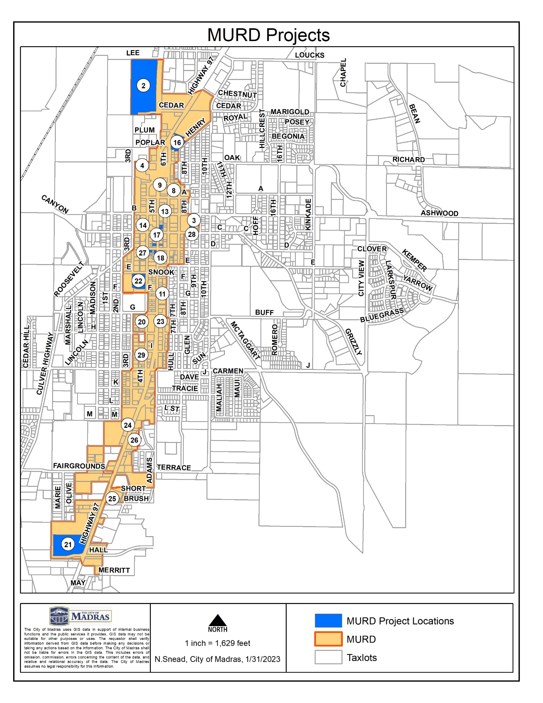Figure 2. Madras Urban Renewal Area Commercial Projects

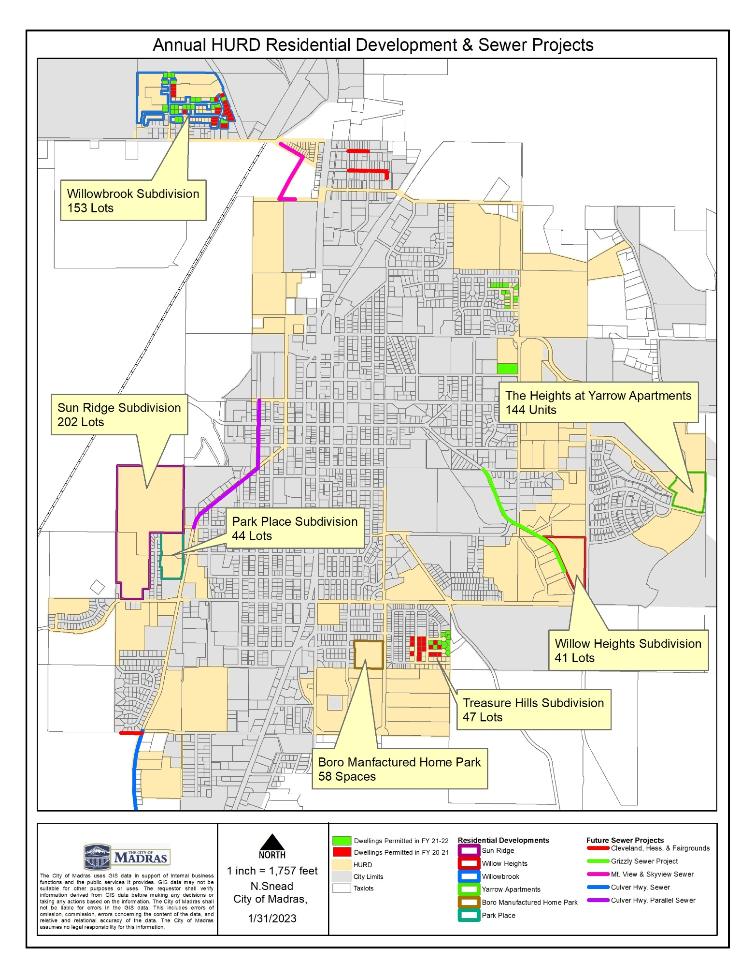Figure 3. Housing Urban Renewal District Projects

Table 15. FY 20-21 & FY 21-22 HURD Home Value Statistics

|  |  |  |
| --- | --- | --- |
|  | **FY 20-21 HURD Home Value Statistics\*** | **FY 21-22 HURD Home Value Statistics\*** |
| Average Home Value | $313,512 | $362,738 |
| Median Home Value | $314,019 | $345,016 |
| Mode of Home Value | $214,243 | $377,493 |
| Minimum Home Value | $162,966 | $264,832 |
| Maximum Home Value | $489,179 | $567,182 |
| Range of Home Values | $326,213 | $302,350 |
| Sum of Home Values | $12,540,491 | $25,028,938 |
| Number of Homes Constructed | 40 | 69 |

*Based on value stated on Development Permit

1. Source: Madras Urban Renewal Agency Revenues and Expenditures Comparison to Budget
2. Source: Madras Urban Renewal Agency Revenues and Expenditures Comparison to Budget